Scheduling and setting parameters
This Chapter dives into how audio parameters are set and scheduled in the Web Audio API. The API’s low-latency precise-timing model enables one to schedule events at specific times in the future. This is crucial for the implementation of automation, envelopes and low frequency oscillator driven effects. Each of the main methods for audio parameters are explored; setValueAtTime(), cancelScheduledValues(), cancelAndHoldAtTime(), exponentialRampToValueAtTime(), linearRampToValueAtTime(), setTargetAtTime(), and setValueCurveAtTime(). Examples are provided for creating a beep sound using these methods to automate gain changes. Cross-fades are then introduced to demonstrate some more advanced parameter automation, happening simultaneously on two sources. Finally, we show how bell sounds can be created using additive synthesis, by applying envelopes to a set of oscillators.

Audio Parameters
All audio nodes have adjustable parameters which can be set, known as AudioParams. They control individual aspects of an AudioNode's functionality, such as the frequency of an oscillatorNode, or the gain applied by a gainNode. An AudioParam can be set immediately to a value using the value attribute, or scheduled to happen at precise times based on the AudioContext's currentTime attribute. Thus, timeline-based automation curves can be set on any AudioParam. And audio signals from the outputs of AudioNodes can be connected to an AudioParam, summing with the intrinsic parameter value.
The Audio Parameters have the following attributes.
- value: The parameter’s current value. It can be set in many different ways, such as setting it directly, applying an automation curve, or having a node’s output connect to it.
- defaultValue: The audio parameter’s initial value.
- minValue: The minimum value that the parameter can take.
- maxValue: The maximum value that the parameter can take.
- automationRate, The audio parameter’s automation rate, which can be either ‘k-rate’ or ‘a-rate’
AudioParam attributes are read only, with the exception of the value attribute. Each AudioParam has a current value, initially set to the AudioParam's defaultValue.
Each AudioParam includes minValue and maxValue attributes that together provide the parameter’s range. For many audio parameters, the minValue and maxValue is intended to be the maximum possible range, from the most negative single float, −(2−2⁻²³)×2¹²⁷ ~ −3.403 × 10³⁸, to the most positive single float value, (2−2⁻²³)×2¹²⁷~ 3.403 × 10³⁸.
Each AudioParam also has an automationRate attribute which specifies how often the parameter can be changed. It is either 'a-rate', meaning that it can be updated once every sample (so at the sample rate of the AudioContext), or 'k-rate', meaning that it can be updated at the beginning of each block of 128 samples. Most audio parameters have automationRates that default to 'a-rate' but can be changed. Choice of automation rate typically depends on whether the value might need to change very rapidly, and whether changes in the parameter value might involve a lot of computation.

Changing Audio Parameters
Let’s consider a ConstantSourceNode, which we call Source. It has one audio parameter, offset. The offset, and hence the output of the node can be set directly and immediately:
source.offset.value = 0.1;
This is the most basic way to change an audio parameter’s value, but it doesn’t provide an easy way to schedule changes at later times. We might, for instance, want the offset to jump to zero exactly one second later. We could use the JavaScript setTimeout to attempt this scheduling, but this is not precise, and timing can depend on other tasks occurring in the main JavaScript thread. We might also want to gradually fade out a music track out. Though this could be achieved with multiple timed changes of the parameter value, this would be a cumbersome and overly complicated way to do it.
The Web Audio API has high precision timing by accessing the audio subsystem’s hardware clock through the AudioContext’s currentTime property. It is used with scheduled source nodes if we want a source to start or stop at specific times, and it also allows parameter changes to be scheduled at precise times in the future.
An AudioParam maintains a list of automation events that specify changes to the parameter’s value over a specific time range. The behavior of an automation event is a function of the AudioContext's current time, as well as the automation event times of this event and of adjacent events in the list.
The Web Audio API provides a convenient set of methods that use and modify this list to gradually change the value of any parameter, cancel changes or hold the value constant. Methods that smoothly change a parameter value are distinguished by how it transitions from one value to another. Furthermore, arbitrary timeline-based automation curves can be set for envelopes on any AudioParam; thus creating fade ins and fade outs, cross-fades, a Doppler effect, filter sweeps, window functions, and so on.

Methods
The behavior of a parameter automation event is a function of the AudioContext's currentTime, the event times and any adjacent events in the list.
There are seven methods that can be applied to an audio parameter.
- setValueAtTime (value,startTime)
- linearRampToValueAtTime(value,endTime)
- exponentialRampToValueAtTime(value,endTime)
- setTargetAtTime(target,startTime,timeConstant)
- setValueCurveAtTime(values,startTime,duration)
- cancelScheduledValues (cancelTime)
- cancelAndHoldAtTime (cancelTime)
In all these methods, times are in the same coordinate system as the AudioContext's currentTime .
Automation event times are not quantized with respect to the sample rate. Thus the curves and ramps are applied to the exact times given when scheduling events.
If an events is added at a time where there is already an events, then it will be placed in the list after that event, but before any later events.

setValueAtTime(value, startTime)
This is the most basic method beyond simply setting the value now. It schedules a parameter value change at the given time. It takes a value and a start time as arguments.
- value: The value the parameter will change to at the given time.
- startTime: The time at which the parameter changes to the given value.
For example, the following snippet sets the gain value of a GainNode to 0 one second from now:
gainNode.gain.setValueAtTime(0, context.currentTime + 1);
If there are no more events after this SetValue event, then the value will remain constant from the startTime onwards until changed by another event.

linearRampToValueAtTime(value, endTime)
This method schedules a linear change in a parameter value from the previously scheduled parameter value to the given value. The value during the time interval T₀≤t<T₁ (where T₀ is time of the previous event and T₁ is the endTime parameter) will be calculated as:
$$v\left(t\right)=V_{0}+(V_{1}-V_{0})(t-T_{0})/(T_{1}-T_{0})$$
Where V₀ is the value at the time T₀ and V₁ is the value parameter passed into this method. If there are no more events after this LinearRampToValue event then for t≥T₁, v(t)=V₁. If there is no event preceding this, the ramp begins at the current time, starting at the current value of the attribute. The exception is when the preceding event is a SetTarget event, which does not have an end time. In which case, T₀ and V₀ are chosen from the current time and value of SetTarget at the moment when the linear ramp is called.
- value: The value that the parameter will linearly ramp to at the given time.
- endTime: The time at which the automation ends.

exponentialRampToValueAtTime(value, endTime)
Many audio parameters are often best changed exponentially since we perceive many aspects of sound in an exponential manner. For instance, doubling signal level represents a 6.02 decibel increase, and doubling frequency represents a one octave increase in pitch.
Thus we have the exponentialRampToValueAtTime method, which schedules an exponential change in parameter value from the previously scheduled parameter value to the given value.
Suppose V₁ and T₁ are the value and endTime parameters, respectively, and V₀ is the parameter value at the time of the previous event T₀. Then the value during the time interval T₀≤t<T₁ is given by:
$$v\left(t\right)=V_{0}{\left(V_{1}/V_{0}\right)}^{\frac{t-T_{0}}{T_{1}-T_{0}}}$$
If V₀ and V₁ have opposite signs, or V₀ is zero, then v(t)=V₀ for T₀≤t<T₁. That is, the parameter won’t ramp at all if the ramp needs to cross or reach 0, but instead will remain fixed at its initial value, then jump to the target value at the endTime.
Setting V₁=0 is not allowed and will generate an error. Instead, one can pick a very small value close to 0 as the target value.
If there are no events after this, then v(t)=V₁ for t≥T₁. If there is no event preceding this, the ramp begins at the current time, using the current value. The exception is when the preceding event is a SetTarget event, which does not have an end time. In which case, T₀ and V₀ are chosen from the current time and value of SetTarget when the ramp is called.
- value The value the parameter will exponentially ramp to at the given time. It must be nonzero.
- endTime The time when the exponential ramp ends. If endTime is less than currentTime, it is clamped to currentTime

setTargetAtTime(target, startTime, timeConstant)
Beginning at the startTime, this method will exponentially move a parameter value toward a target at a rate given by a time constant. The parameter value at time t is given by
$$v\left(t\right)=V_{1}+\left(V_{0}-V_{1}\right) e^{-\left(t-T_{0}\right)/τ}→V_{1}$$
during the time interval t ≥T₀, where T₀ is the startTime, V₀ is the initial parameter value at T ₀, V₁ is the target value, and τ is the timeConstant parameter. This method is useful for implementing decay and release portions of an ADSR envelope.
Changes in the value become smaller and smaller as it gets closer and closer to the target. Note though, that it converges on the target, but never reaches it.
If a LinearRampToValue or ExponentialRampToValue event follows this event, the behavior is described in linearRampToValueAtTime() or exponentialRampToValueAtTime(), respectively. For all other events, the SetTarget event ends at the time of the next event.
The method takes the following parameters.
- target: The value that the audio parameter will start changing to at the given time.
- startTime: The time at which the exponential approach will begin.
- timeConstant: The time constant, in seconds, of an exponential smoothing filter approach to the target value. The larger this is, the slower the transition will be. If the time constant is zero, the output value jumps immediately to the final value.
A little bit of explanation is in order here. The time constant is the time it takes a first-order linear continuous time-invariant system to reach the value 1-1/e (around 63.2%) given a step input response (transition from 0 to 1 value). Suppose we have a step response. So T₀=0, V₀ =0, and V₁ =1. Then for setTargetAtTime, the parameter value at time t becomes
$$v\left(t\right)=1- e^{-t}$$
And at time t= τ, the parameter has the expected value, 1-1/e.

setValueCurveAtTime(values, startTime, duration)
This method offers the most flexibility in scheduling parameter changes. It sets parameter values starting at the given time for the given duration, based on an array of arbitrary parameter values. The number of values will be scaled to fit into the desired duration. It is equivalent to having a sequence of linearRampToValueAtTime calls.
Let T₀ be startTime, T_{D} be duration, V be the values array, and N be the length of the values array. Then, during the time interval: T₀≤t<T₀+T_{D}, let
$$k=\left\lfloor (N-1)\left(t-T_{0}\right)/T_{D}\right\rfloor$$
v(t) is computed by linearly interpolating between V[k] and V[k+1]. That is, the array indices map to equally spaced intervals over the duration, and the value at any time during that duration is found by interpolating the values of the two array elements corresponding to the closest sampled times over the duration.
After the end of the curve time interval (t≥T₀+T_{D}), the value remains constant at the final curve value until there is another automation event. The value at time T₀+T_{D} is set to V[N−1] so that any further automation will start from where the setValueCurveAtTime() ended.
The method takes the following parameters.
- values: This is an array of floats representing a parameter value curve. These values apply starting at the given time and lasting for the given duration. When this method is called, a copy of the curve is created and used in setting up the automation events, so modifying the values array after the method has been called will have no effect on the audio parameter.
- startTime: The time at which the value curve will be applied. If startTime is less than currentTime, it is clamped to currentTime.
- duration: The amount of time in seconds (after the startTime parameter) where values will be calculated according to the values parameter.
No other events or automation methods can occur over the time period of the setValueCurveAtTime method, [T₀, T₀+T_{D}). This interval excludes the endpoint T₀+T_{D}, so another event could be scheduled precisely at that time.

cancelScheduledValues(cancelTime)
These last two methods are concerned with how to cancel scheduled events. cancelScheduledValues will cancel all scheduled parameter changes with times greater than or equal to the cancelTime. Any active automations that are active at the cancel time are also cancelled, even if they started before the cancel time.
- cancelTime The time after which any previously scheduled parameter changes will be cancelled. If cancelTime is less than currentTime, it is clamped to currentTime.

cancelAndHoldAtTime(cancelTime)
Like cancelScheduledValues(), this will cancel all scheduled parameter changes at or after the cancelTime. But now, the value that would have happened at cancelTime is kept and held until other automation events are introduced. The method has the same parameter as cancelScheduledValues.
- cancelTime The time after which any previously scheduled parameter changes will be cancelled. If cancelTime is less than currentTime, it is clamped to currentTime.
The implementation of this method depends on what sort of other automations are running. If there are no scheduled events on the parameter, then the automation value after cancelAndHoldAtTime() is the value that the original timeline would have had at the cancelTime t_{c}. Now suppose there is an event, such as a linear ramp, exponential ramp, setTarget or setValueCurve, which ends at some time after t_{c}. Then that curve continues as it would have done up to t_{c}, but then remains fixed at the value of the curve for time t_{c}. This is illustrated in 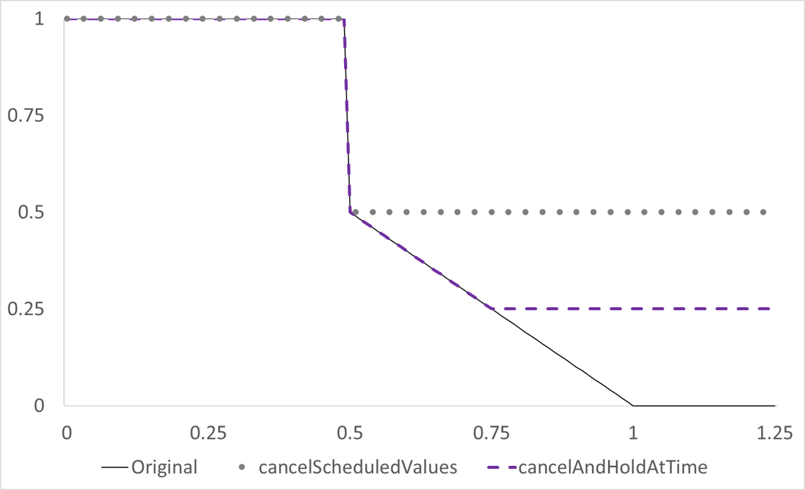.1. Any further events are removed.

Figure 5.1. How canceling operates when there is an ongoing scheduled event on a parameter. Originally, the parameter value is set to 0.5 at time 0.5, then ramped down to 0 over half a second. cancelScheduledValues at time 0.75 will remove this ramp so that the parameter remains fixed at 0.5. cancelAndHoldAtTime at time 0.75 will keep the ramp until time 0.75, then hold it at whatever value it has at that point in time.

Computation of Value
There are two different kind of audio parameters, simple parameters and compound parameters. Simple parameters (the default) are used on their own to compute the final audio output of an audio node. Compound parameters are audio parameters that are used with other audio parameters to provide a computedValue, which is then used internally in the processing of an AudioNode.
An example of a compound parameter is the computed frequency of an oscillator, which is based on the frequency and detune audio parameter values.
Computation of an audio parameter’s value involves the IntrinsicValue computed from the value attribute and any automation events, and the ComputedValue that is the final value controlling the audio processing. The ComputedValue is the sum of the IntrinsicValue value and the values of any audio streams connected to the input AudioParam buffer, see Chapter 6. If this audio parameter is a compound parameter, compute its final value is also based on other audio parameters.
The nominal range for a computedValue are the lower and higher values this parameter can effectively have. For simple parameters, the computedValue is clamped to the nominal range for that parameter. Compound parameters have their final value clamped to their nominal range after having been computed from the different AudioParam values they are composed of.
When automation methods are used, clamping is still applied. However, the automation is run as if there were no clamping at all. Consider the following automation sequence;
Node.param.setValueAtTime(0, 0);
Node.param.linearRampToValueAtTime(2,0.5);
Node.param.linearRampToValueAtTime(0,1);
If there were no restrictions on the range of the parameter, it would ramp up to 2 over half a second, then ramp down to 0 over the next half second. But if the AudioParam has a nominal range of [0,0.5], the actual value stays constant at 0.5 whenever it would have been greater than 0.5. This is shown in Figure 5.2, where the dashed line indicates what would have happened without clipping, and the solid line indicates the actual expected behavior of the AudioParam due to clipping to the nominal range.

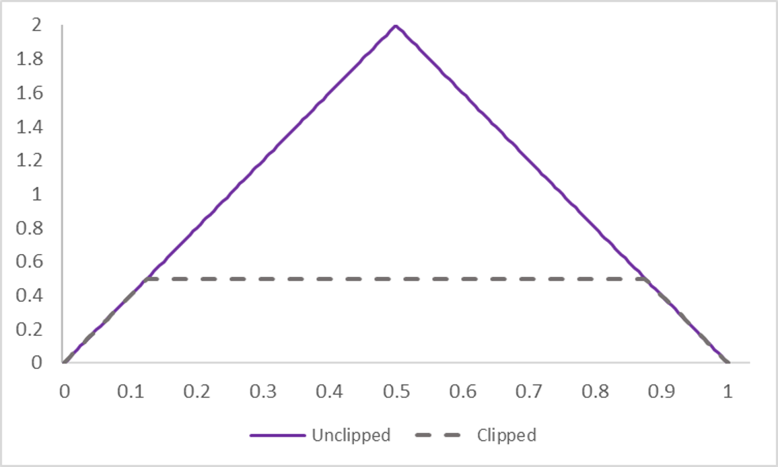.2. An example of clipping of an audio parameter automation from the nominal range.

Example – Beep sound with parameter automation
<input type='button' value='Beep' id='triggerBeep'>
<p>Frequency</p>
<input type='number' id='Frequency' min=0 max=8000 value=440>
<p>Attack</p>
<input type='number' id='Attack' min=0 max=1000 value=50>
<p>Decay</p>
<input type='number' id='Decay' min=0 max=1000 value=50>
<script src='Beep.js'></script>

var context = new AudioContext()
var Volume = new GainNode(context,{gain:0})
var Tone = new OscillatorNode(context,{type:'sawtooth'})
Tone.connect(Volume)
Volume.connect(context.destination)
Tone.start()
triggerBeep.onclick = function() {
context.resume()
let now = context.currentTime
Tone.frequency.value = Frequency.value
Volume.gain.setValueAtTime(0.0, now)
Volume.gain.linearRampToValueAtTime(1,now + Attack.value/1000)
Volume.gain.linearRampToValueAtTime(0,now + Attack.value/1000 + Decay.value/1000)
}

Code example 5.1. Beep.html and Beep.js, which demonstrate audio parameter automation.
Code example 5.1 shows use of parameter scheduling to create a beep sound. The sound is based on a sawtooth wave with rapidly rising (attack) and decaying envelope. A sawtooth wave is generated and connected to a gain node with gain set to 0. When the triggerBeep button is clicked, the gain node’s gain parameter is ramped up to 1 over the duration of the attack phase, then ramped back down to 0 over the duration of the decay phase.
Note that for scheduling the linear ramp for the decay phase, we need to set the end time of the ramp to be based on both the attack time and the decay time. The ramp begins at the end of the last scheduled event, now + Attack.value/1000 and ends at now + Attack.value/1000 + Decay.value/1000. So its duration is just the difference between the begin and end times, Decay.value/1000.

Example – Beep sound with custom automation
<input type='button' value='Beep' id='triggerBeep'>
<p>Duration</p>
<input type='number' id='Duration' min=0 max=1000 value=50>
<script>
var context = new AudioContext()
var Volume = new GainNode(context,{gain:0})
var Tone = new OscillatorNode(context)
Tone.connect(Volume).connect(context.destination)
Tone.start()
var curve = new Float32Array(100)
for (i=0;i<100;i++) curve[i]=Math.sin(Math.PI*i/99)
triggerBeep.onclick = function() {
context.resume()
Volume.gain.setValueCurveAtTime(curve,0,Duration.value/1000)
}
</script>

Code example 5.2. SetValueCurve.html, which creates a beep sound using a custom automation curve.
linearRampToValueAtTime() and exponentialRampToValueAtTime() are both just pre-defined automation curves. The setValueCurveAtTime() method allows one to set arbitrary automation curves. So we can define the structure of the envelope for the previous code example to be whatever we want.
In Code example 5.2, we have provided a simple example of use of SetValueCurveAtTime. We made the automation curve follow a half period of a sine wave, rising from 0 to 1 and back down again. Note that we've sampled the sine wave so that the very last point is sin(π99/99)=0, so that the gain returns to 0 at the end of the automation. A better way to do this would be to apply a setValueAtTime after the SetValueCurveAtTime, thus forcing the gain to return to 0 regardless of its value after automation. Also, we didn't use the currentTime as the second argument to SetValueCurveAtTime. We could have, but by calling the method with a start time of 0, it starts immediately anyway.

Example – Repeating a beep
Now suppose one wants to create something like a metronome, or a heart monitor, or a ticking clock. The individual sounds over one period could be created with parameter automation, but how can we make the automation endlessly repeating? The Web Audio API does not provide this feature directly, but there are various ways to do it.
The simplest way to loop parameter automation, but probably not the preferred way, is to use the Javascript setInterval() method. setInterval takes two arguments; a function that will be called repeatedly, and the time interval in milliseconds between each call of the function. The first call does not happen immediately, it happens after the first interval has elapsed.
Use of setInterval to have a beep repeat is shown in Code example 5.3. The beep is created in the same way as it was in Code example 5.1, but to keep the code short, we used fixed values of Attack and Decay as 100 milliseconds.
<input type='button' value='Repeat beep' id='triggerBeep'>
<script>
var context = new AudioContext()
var Attack=100,Decay=100
var Volume = new GainNode(context,{gain:0})
var Tone = new OscillatorNode(context)
Tone.connect(Volume).connect(context.destination)
Tone.start()
triggerBeep.onclick = function() {
context.resume()
var interval = setInterval(function(){
let now = context.currentTime
Volume.gain.setValueAtTime(0.0, now)
Volume.gain.linearRampToValueAtTime(1, now + Attack/1000)
Volume.gain.linearRampToValueAtTime(0, now + Attack/1000 + Decay/1000)
},1000)
}
</script>

Code example 5.3. repeatBeep.html, showing how parameter automation can be looped using JavaScript's setInterval method.
clearInterval() can be used to stop the repeating calls, where clearInterval takes the name of the function that was used in setInterval() as its argument. For this to work, the function must have been named.
Note that the time interval here is given in milliseconds, not seconds. That’s because setInterval is not part of the Web Audio API. It uses Javascript's clock, not the WebAudioAPI's clock. The Javascript clock is accurate only up to a millisecond. So calls using that clock, like setInterval(), clearInterval(), setTimeOut() and DateNow(), require a time to be specified in an integer number of milliseconds. The Web Audio API's clock has far higher precision, at least as high as the sampling rate. So methods such as setValueAtTime specify a time as a double value in seconds.
In addition to the imprecision of the Javascript clock, this clock is on the main execution thread. So the actual timing of the calls can be affected by everything else happening outside the audio context; loading files, garbage collection, layout rendering on the webpage, and so on. For these reasons, using setInterval and other Javascript timing methods to control Web Audio automation is not recommended.
So how else can one get a repeating beep? One can use a for loop to define the timing of some finite number of beeps. However, the loop is then not infinite. Another option could be creating a buffer source node with the result of parameter automation in the buffer, and starting that node with loop set to true. But then a new buffer needs to be created if one wants to change the beep sound, and the attack and decay of the beep can't be changed while it is rendered. One more option could involve still using setInterval(), but set the interval time to some value much shorter than the time of the beep. and only set the timing in the parameter automation calls. So we space out timing of when parameter automations are defined, but don't suffer the Javascript clock's timing issues. Though still using the Javascript clock, all the actual timing of beeps would be based on the Web Audio clock.

Example - Cross-fade
Consider scheduling a crossfade where one source fades out while the other source fades in. We transition between the two sources by scheduling a gain increase on one source, and a gain increase on the new source.
The question then, is what sort of curves should be used for these increases and decreases? A first choice could be a linear fade over sone duration D. That is, the gains applied to the two sources are $G_{1}(t)=1-t/D$ for a fade out of the first source and $G_{2}(t)=t/D$ for a fade in of the second source. However, loudness is related to power, and instantaneous power is the sum of the squares of the signals divided by the number of signals. So with a linear fade, the loudness level can appear to change, since the power of the signal varies over time.
To keep the power constant, we need a function for the gains where ${G_{1}(t)}^{2}+{G_{2}(t)}^{2}$ is constant. A good choice is setting the gains to cosine and sine functions, since $\cos^{2}x+\sin^{2}x=1$ for any x.
Code example 5.4 shows simple code for performing a crossfade. Here, we have two different oscillators, each connected to gain nodes and then on to the destination. The gain of the first oscillator is initially set to 1, and the gain on the second oscillator is set to 0. If the Linear Crossfade button is clicked, the first oscillator's gain linearly ramps down and the second oscillator's gain linearly ramps up. If the Equal Power Crossfade button is clicked, the ramps follow the form of sine and cosine functions from 0 to π/2, so that the gains go from 1 to 0 (fade out) and 0 to 1 (fade in), and power is preserved.
<input type='button' value='Start' onclick='context.resume()'>
<input type='button' value='Linear Crossfade' id='CrossfadeLinear'>
<input type='button' value='Equal Power Crossfade' id='CrossfadeEqualPower'>
<p>Duration</p>
<input type='range' id='Duration' min=0 max=10 value=5 step='any'>
<script src='Crossfade.js'></script>

var context = new AudioContext()
var Tone1 = new OscillatorNode(context,{type:'sine',frequency:500})
var Tone2 = new OscillatorNode(context,{type:'sine',frequency:300})
var Gain1 = new GainNode(context,{gain:1})
var Gain2 = new GainNode(context,{gain:0})
Tone1.start()
Tone2.start()
Tone1.connect(Gain1).connect(context.destination)
Tone2.connect(Gain2).connect(context.destination)
var N=100
var curveUp = new Float32Array(N), curveDown = new Float32Array(N)
for (i=0;i<N;i++) curveUp[i] = Math.sin(0.5*Math.PI*i/(N-1))
for (i=0;i<N;i++) curveDown[i] = Math.cos(0.5*Math.PI*i/(N-1))
CrossfadeEqualPower.onclick = function() {
let now = context.currentTime
Gain1.gain.setValueCurveAtTime(curveDown,now,Duration.value)
Gain2.gain.setValueCurveAtTime(curveUp,now,Duration.value)
}
CrossfadeLinear.onclick = function() {
let now = context.currentTime
Gain1.gain.value=1
Gain2.gain.value=0
Gain1.gain.linearRampToValueAtTime(0,now + parseFloat(Duration.value))
Gain2.gain.linearRampToValueAtTime(1,now + parseFloat(Duration.value))
}
Code example 5.4. Crossfade.html and Crossfade.js, which use setValueCurveAtTime to show the difference between a linear crossfade and an equal power crossfade of two signals.
The code here was written so as to highlight a few aspects. The setValueCurveAtTime and the linearRampToValueAtTime methods have different forms. linearRampToValueAtTime starts from whatever the current value is. So if we want the crossfade to always ramp down the first signal from 1 and ramp up the first signal from 0, we need to reset the gain terms. But we don't need to do that for setValueCurveAtTime since the ramp will start from whatever is the first value in the array of curve values.
Also, the value of a range control is actually a string. Not a float. For the setValueCurveAtTime method, that string is converted directly to a number. But if we had used linearRampToValueAtTime(0,now + Duration.value) it would have tried to combine now and Duration.value into a single string first. So we needed to parse the string Duration.value into a float first.
This code may still cause errors if one tries to perform another crossfade while the scheduled values from an existing setValueCurveAtTime have not yet completed. So one should have a cancelScheduledValues method invoked before applying setValueCurveAtTime.
In this example, we purposefully left these issues in the code. But it’s a good idea to call parseFloat when getting the string value of a control when you need the associated number, and a good idea to cancel the scheduled values when you know that you don't want them. Even if you don't expect these errors to occur, there may be unusual circumstances that could arise, and you also want the code to be robust against future changes.
Finally, there are many other forms for fade in and fade out curves, and hence for the crossfade. For instance, an exponential amplitude fade is often considered to sound more natural than a linear amplitude fade. See https://manual.audacityteam.org/man/fade_and_crossfade.html for a summary of some popular choices.

Example – Synthesising a bell sound
Sinusoidal modeling is a form of sound synthesis based on the idea that audio signals can be represented as a sum of sine waves with time-varying amplitudes and frequencies. In a sense, this is an extension of the Fourier series, which expands a periodic signal as a sum of sines and cosines.
We don't dive into sinusoidal modelling synthesis here. But rather, we use the sinusoidal model to render an approximation of a signal. We work with a bell, since the sound produced by striking a bell is well represented by decaying harmonic components. So the time-varying nature of the signal is simplified. To render this sound, we need to specify;
- A number of oscillators,
- the frequency of each oscillator,
- the initial amplitude for each oscillator,
- and the decay rate for each oscillator.
Then, we apply an automation curve to the gain applied to each oscillator. This is done in Code example 5.5. A recording of a bell (the famous Big Ben clock bell in central London) was analysed to extract frequencies, initial amplitudes and decay rates for the 14 strongest harmonic components. A Params object stores these values.
<input type='button' value='Strike' id='Strike'>
<p>Duration</p>
<input type='range' min=0.2 max=4 value=1 step='any' id='Duration'>
<p>Pitch</p>
<input type='range' min=0 max=4 value=1 step='any' id='Pitch'>
<script src='Bells.js'></script>

var context = new AudioContext()
var DBToAmp = function(db) { return Math.pow(10, db / 20) }
Strike.onclick = function() {
context.resume()
var gNode=[],osc=[],FinalAmp
for (i=0;i<Params.nOsc;i++) {
gNode[i]=context.createGain()
osc[i]= context.createOscillator()
osc[i].start()
osc[i].connect(gNode[i]).connect(context.destination)
}
var now = context.currentTime
for (i=0;i<Params.nOsc;i++) {
osc[i].frequency.setValueAtTime(Pitch.value*Params.F[i],now)
gNode[i].gain.setValueAtTime(DBToAmp(Params.Amp0[i]), now)
FinalAmp=DBToAmp(Params.Amp0[i]+Params.Slope[i]*8/Duration.value)
gNode[i].gain.exponentialRampToValueAtTime(FinalAmp,now+8)
gNode[i].gain.linearRampToValueAtTime(0, now + 12)
}
}
Params= {
nOsc:14,
F:[97.0362,155.7461,200.6708,291.5601,335.2872,401.6002,500.6919,
599.8203,679.0558,704.6314,850.3987,1016.353,1169.165,1343.452],
Slope:[-0.71286,-1.08551,-2.68134,-0.80383,-5.88471,-1.06387,-3.419,
-3.69923,-6.71634,-3.57097,-6.85307,-7.04044,-5.6755,-7.25273],
Amp0:[ -55.7976,-44.8857,-33.3415,-70.8675,-24.9633,-75.653,-27.2338,
-66.8294,-23.635,-57.3287,-43.0425,-50.9267,-55.1784,-46.6498]
}
Code example 5.5. Bells.html and Bells.js, showing how to synthesise a bell-like sound using parameter automation to create a sum of decaying harmonics.
There are controls to change shift the frequencies (and hence the overall pitch) and change the duration of the bell sound that will be produced.
All the processing happens when the Strike button is clicked. The onclick method contains two For loops. The first one simply sets up the audio graph, which is the 14 oscillators connected to gain nodes, connected to the destination. The gains are all initially set to zero.
The second for loop implements the parameter automation. The oscillators' frequency and gain nodes' initial gain parameters are set to the assigned values. The amplitude decay rates are given as linear curves in decibels. So we convert the decibel values to linear scale, and apply exponential ramps over 8 seconds. Remember that the exponentialRampToValueAtTime can't ramp a parameter all the way to 0. So after the 8 second exponential decay has finished, a linear ramp to 0 is applied for 4 seconds.
This simple approximation sounds quite good. And by just changing the Params object, one could model many different bell-like sounds.
To refine it further, an attack could be applied rather than instantaneously setting amplitudes to their maximum values, start times may differ for different harmonics, some shaped noise could mode the burst of many quickly decaying sinusoids when the bell is first struck, and the decay could be modeled with a more complex structure than an exponential ramp.

